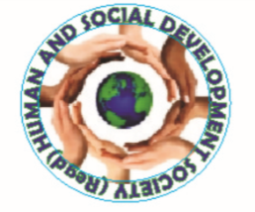**HUMAN & SOCIAL DEVELOPMENT SOCIETY**

**Annual Report 2019-20**

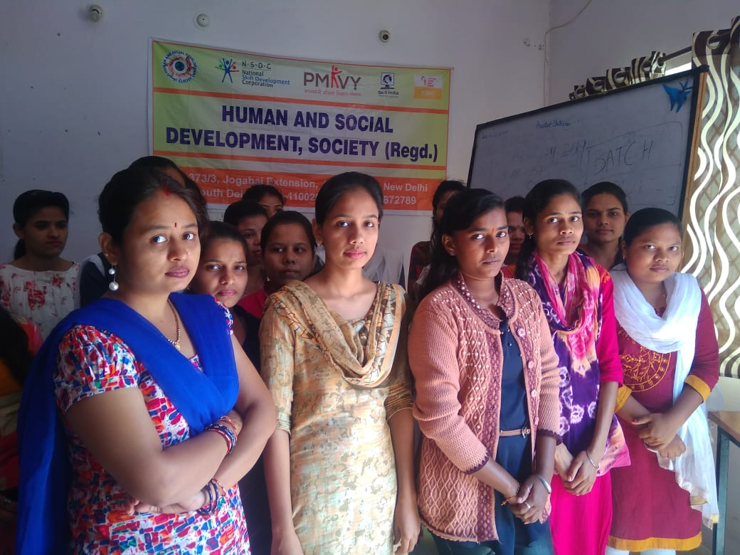

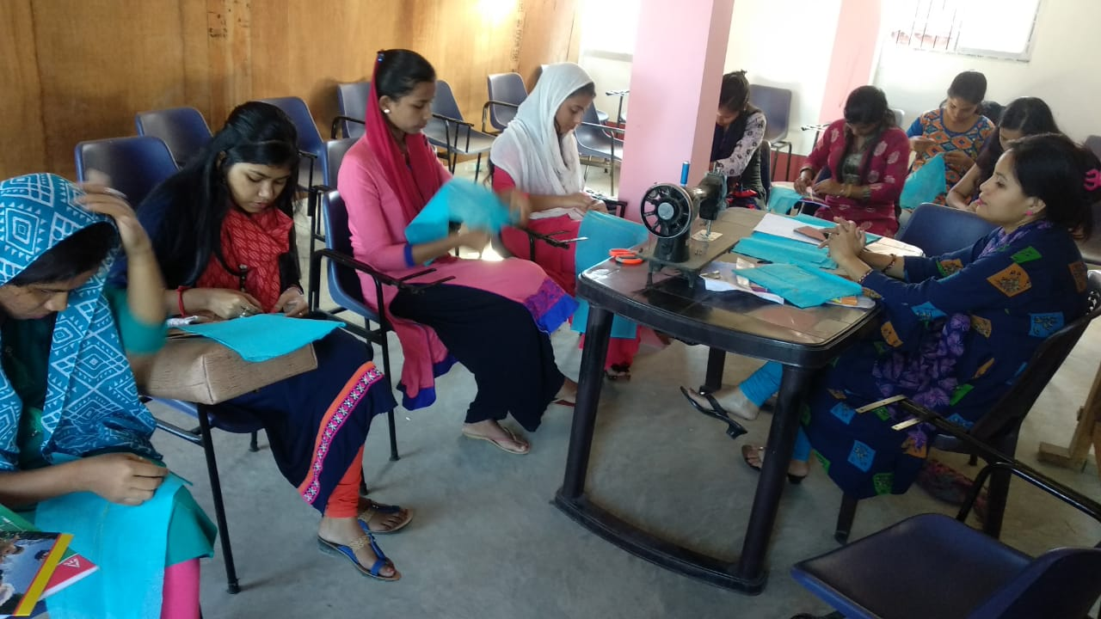

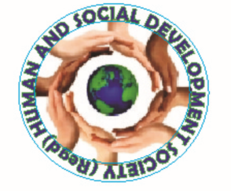

**HUMAN & SOCIAL DEVELOPMENT SOCIETY**

**Human & Social Development Society** is Registered as a non- profit organisation in India. It was registered as a society on 20 May 2005 under the Societies Registration act XXI, 1860. The organisation primarily works for the upliftment of weaker and marginalised section of the society across the nation. The major areas of the work include education, focusing on Girls Education, Health, computer literacy, Legal awareness, social welfare and empowerment.

**Mission:**

In order to strengthen and empower the weaker and marginalised section of the society, the mission of the organisation to focus on various developmental initiative such as:

* **Education**
* **Employment**
* **Awareness**
* **Social Welfare**
* **Accessible environment**
* **Cultural**

**Vision:**

A Society full of educated youths having the skills required to build their prospective life successful and productive for the nation.

**Objectives:**

1. To promote literacy, cultural and other social activities by awareness programs, adult education classes, SarvShikshaAbhiyan, lecture, essay competitions, exhibitions, symposium, cultural programs, press conferences and seminars.
2. To work for Educational, Social and Economic development of community to make them self-depended and self-reliance.
3. To arrange industry based skill development programme.
4. To arrange, start and manage the different training courses which are helpful to learn Computer and Information Technology.
5. To start various kinds of training courses like- Teachers Training, Nurses Training, Vocational Training, Technical and Non-Technical Courses after getting the permission and / or affiliation from the competent authority/ authorities, if it is required.
6. To create a sense of brotherhood, co-operation, mutual harmony, love and affection among the community and country.
7. To promote the cause of national integration and unity of India and fight against the forces of separatism in India.
8. To aware the general public about the fundamental rights provided by the constitution of India.
9. To start, establish, run, take over or manage and maintain the schools, with the object to provide sound nursery, primary, middle, secondary, senior secondary and higher education to children/ students by seeking recognition and affiliation from the education department etc.
10. To organize seminar, conference, symposium, meetings, press conference, debate, lectures and other lawful gatherings on different issues from time to time.
11. To arrange and organize EYE and Blood donation camps.
12. To work for HIV/AIDS free India
13. To start various programs against child labour and take up effective, reasonable and lawful steps in these connections for welfare of children.
14. To establish and maintain institutions for the handicapped, blind, deaf, dumb, poor, SC, ST, Backward classes, minorities and other needy people to provide the training of house hold industries, semi-skilled jobs and also to provide them other required facilities like Hostel, Medical Aid, Food, Cloth, Transportations, and economic assistance to start new business.
15. To work for women empowerment in all aspect of life.
16. To work related to welfare, care and protection for disable persons.
17. To collect Information, Notices, Notifications, Policies from the government, Semi Government, National/International Agencies and N.G.Os and also provide the same to the trust and also to the general public.
18. To grant scholarship to meritorious students and provide financial aid to poor students.
19. To provide free legal and medical aid, social economic help and assistance to the needy persons.
20. To promote and create awareness and research in the field of Health, Education and other issues.
21. To work for BetiBachao, BetiPadao and Swachh Bharat Mission.
22. To conduct Training and Research programs for Pollution Control (in Water, Air, Soil, Earth, Atmosphere), Polluted Diseases and to maintain/ develop and also protect the Herb's, Forests, Environment, Species of the Animals, Birds, Wild Life and other Natural Gifts helping to support the preservation of Environment.
23. To work for global warming and environment.
24. To approach and to encourage the people to donate Blankets, Rugs, Woolen/Cotton/Silken, cloths and other articles of daily use to men, women and children.
25. Trust can work in co-operation/collaboration/support by Government/Non-Government, voluntary organization for the welfare and upliftment of the needy section of the society.
26. To engage, employ or hire appropriate staff, workers, legal experts and others professionals, attorney, managers, and agents, for the work and attainment of the aims and objects of the trust and to pay those wages, salaries, stipends and fees.
27. To receive financial and non-financial assistance from government, non-government organization, international agencies, banks and any other legal entity or individual.

**SKILL DEVELOPMENT PROGRAM FOR YOUTHS.**

1. The society has train & Place 795 youths across the country. The basic motive of this training was to empower them through digital literacy. The program included basic computer literacy, hardware& networking. After training they were placed in various industries.**Human and Social Development Society is training partner of NSDC, TSSC & NABARD.**
2. 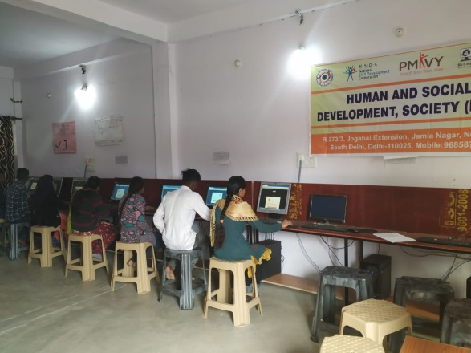
3. 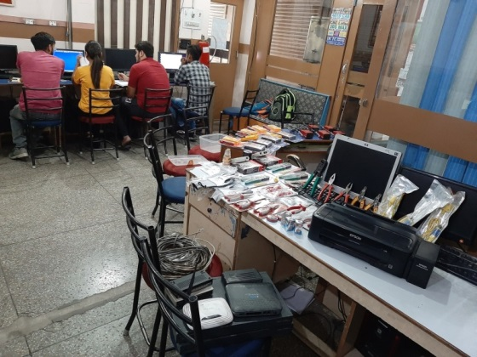

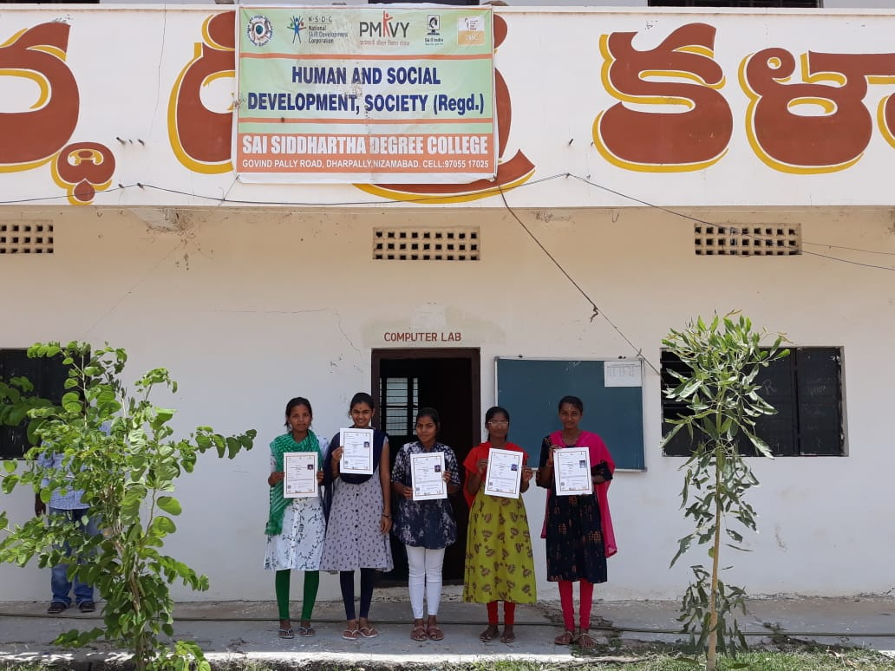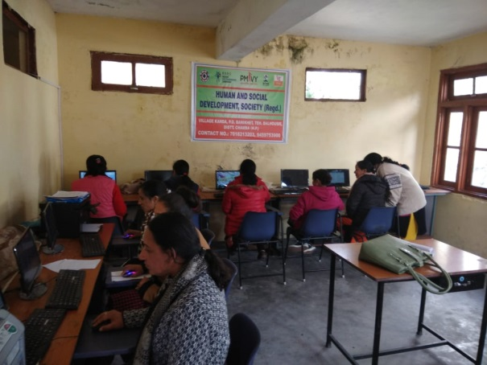

**Skill Development Saharanpur. UP**

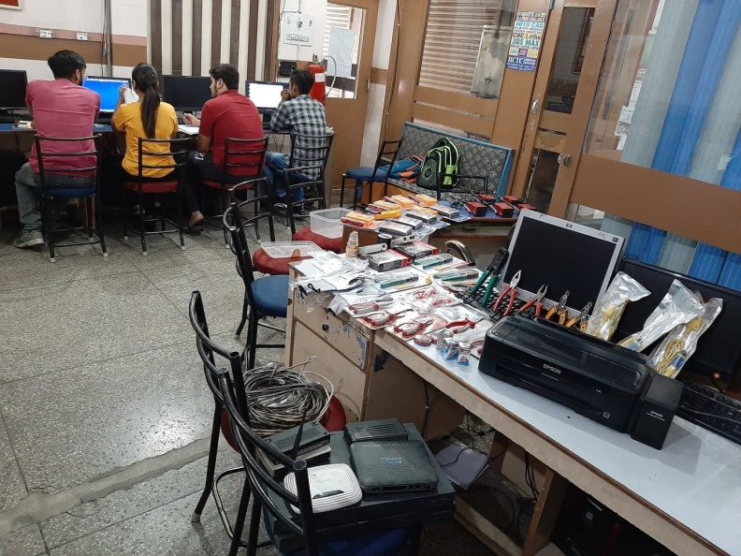

**Skill Development Centre Telangana**

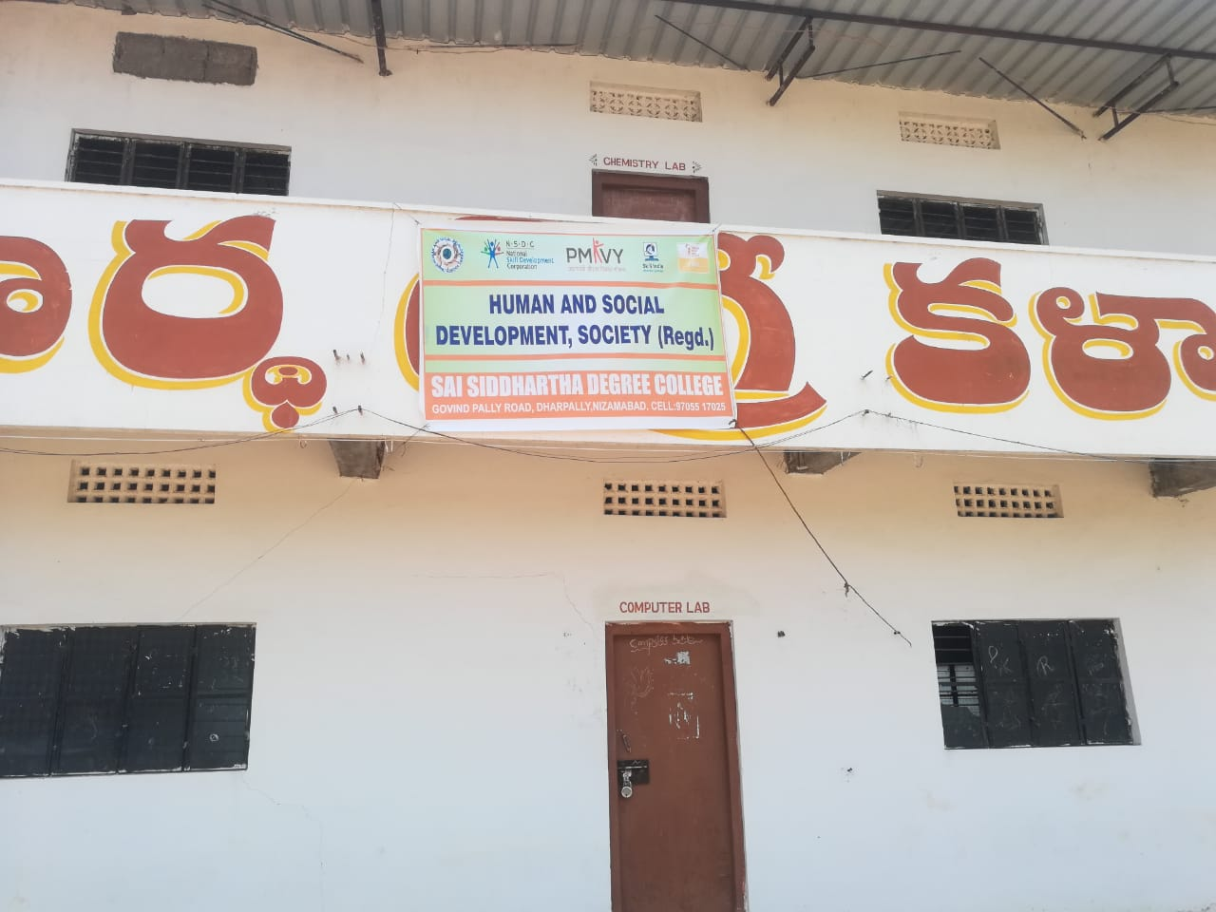

**Skill Development Centre Delhi**

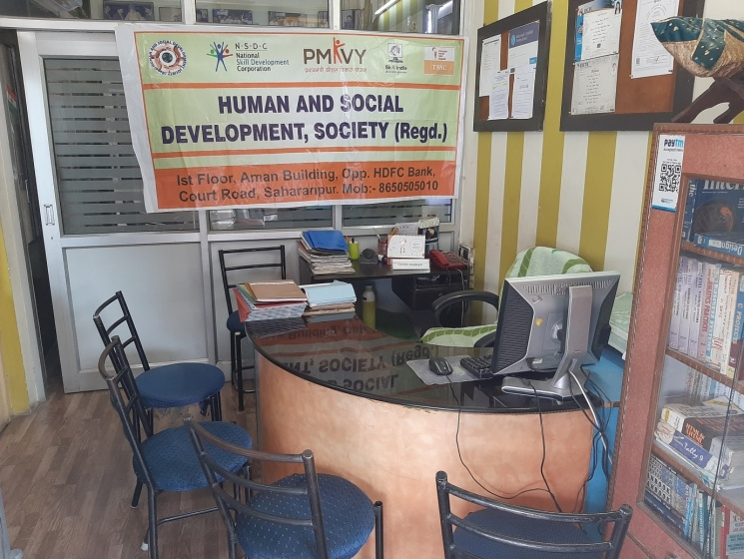

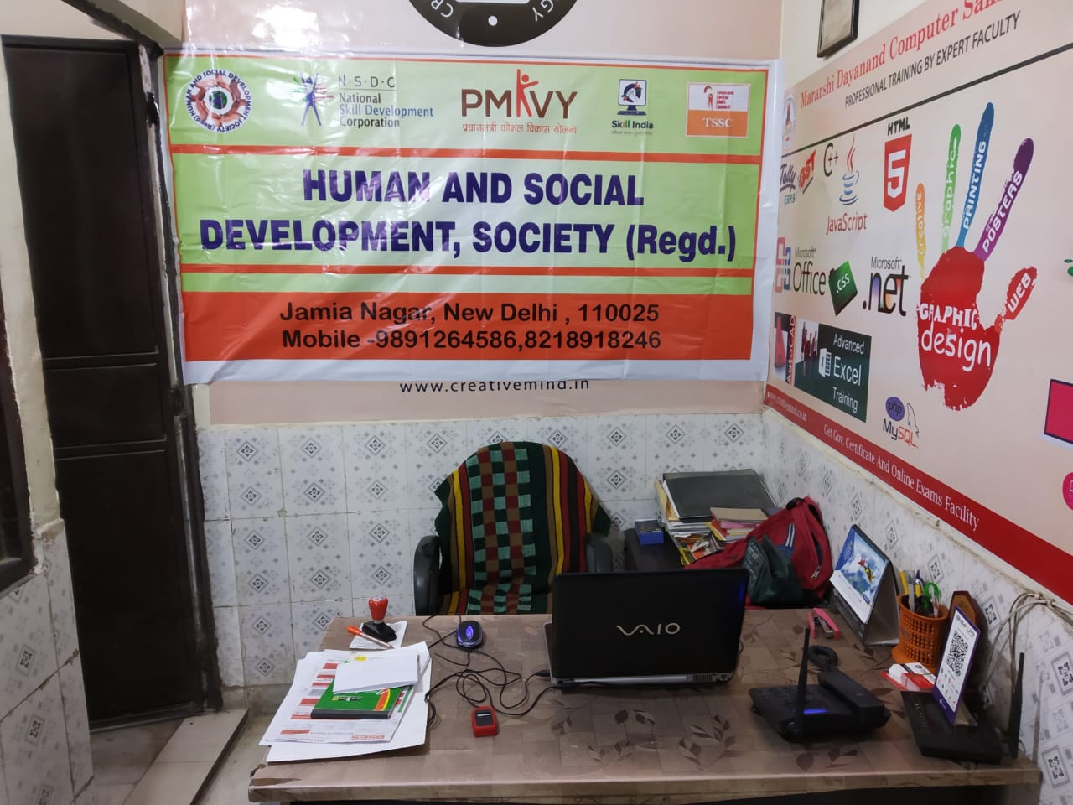

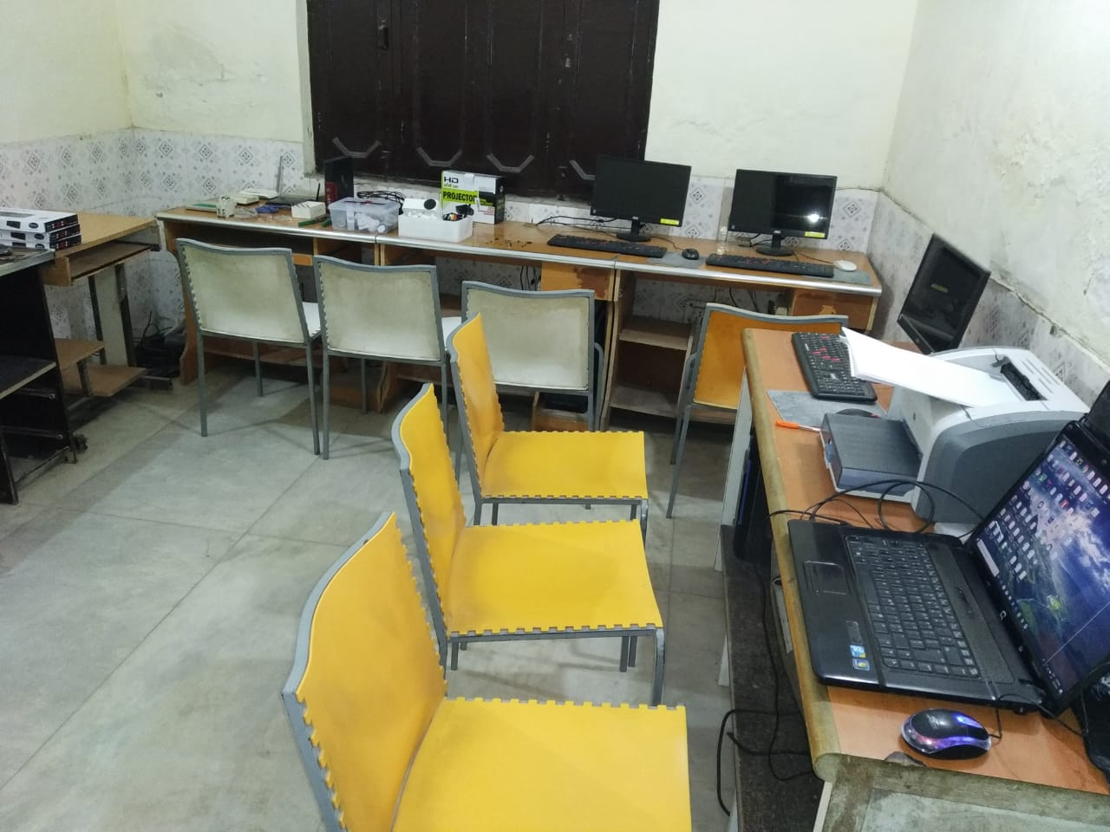

**Skill Development Centre Himachal Pradesh**

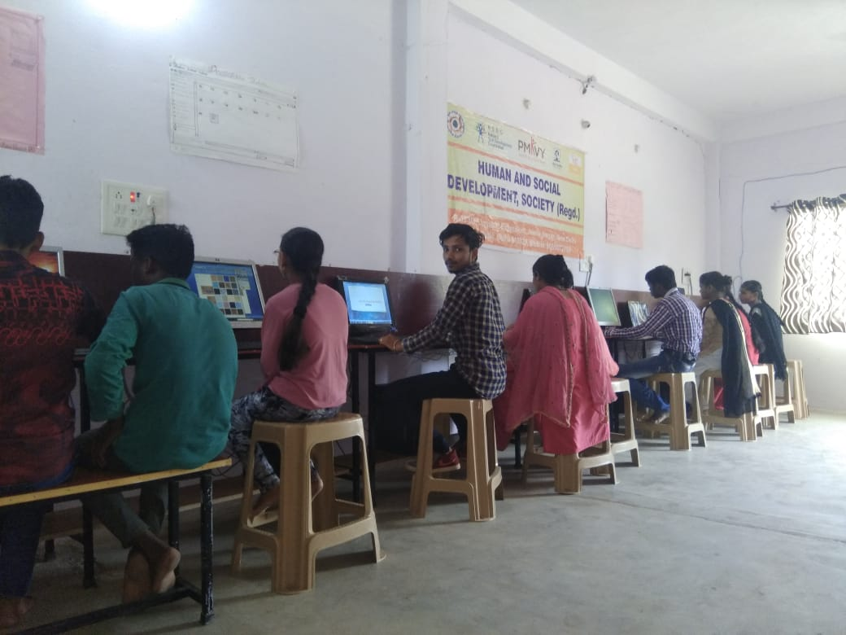

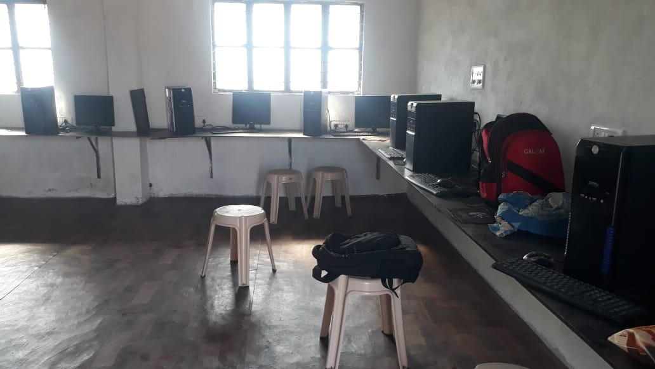

**Free Aye Check-up Camp.**

This was one of the most important activities done by the organisation during this financial year. A two day Free Eye Check-up camp was organised in Okhla near the Dhobi Ghat slum area from 9:00 am to 4:00 pm. Dr.Riyaz hmed with his team were called for free Eye check ups. People came for check ups and discussed their problems with doctor and his team. Some of the patients were distributed medicines. People were also made aware about the healthy hygienic habits. Regular check ups and importance of donating blood regularly.

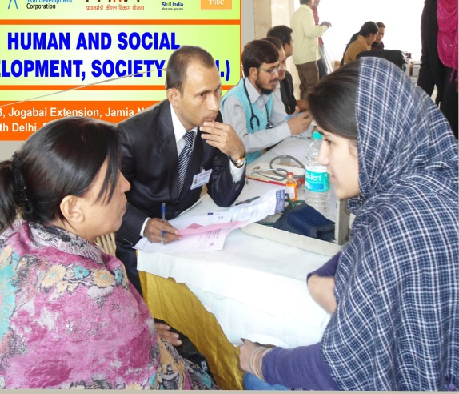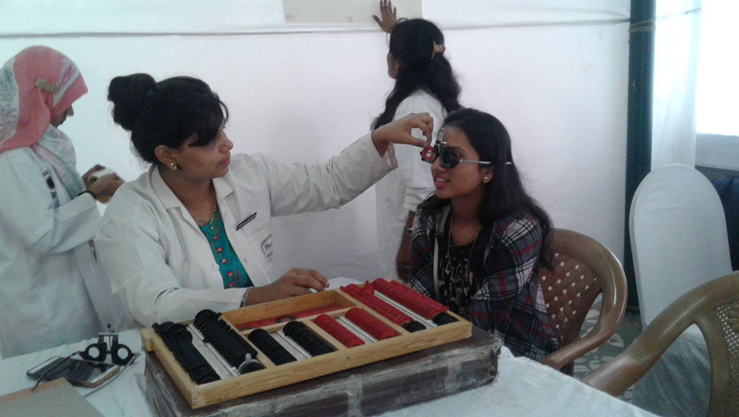

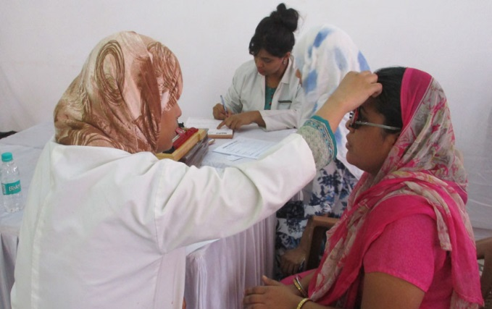

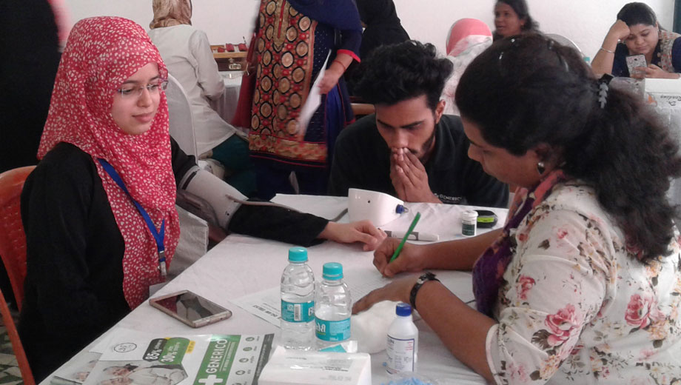

**Cutting & Tailoring Training.**

We have trained 20 girls in 2 Months. In this training we trained basic Cutting & tailoring. This program speciallyfor those girls and women who do not want to go outside for employment. During the training we gave them also some safety tips.

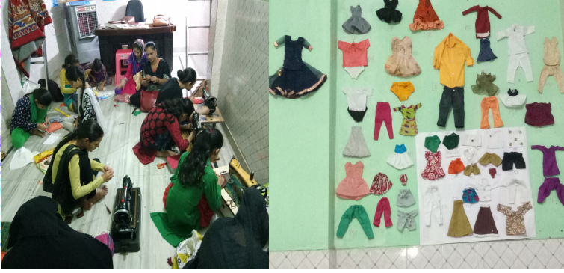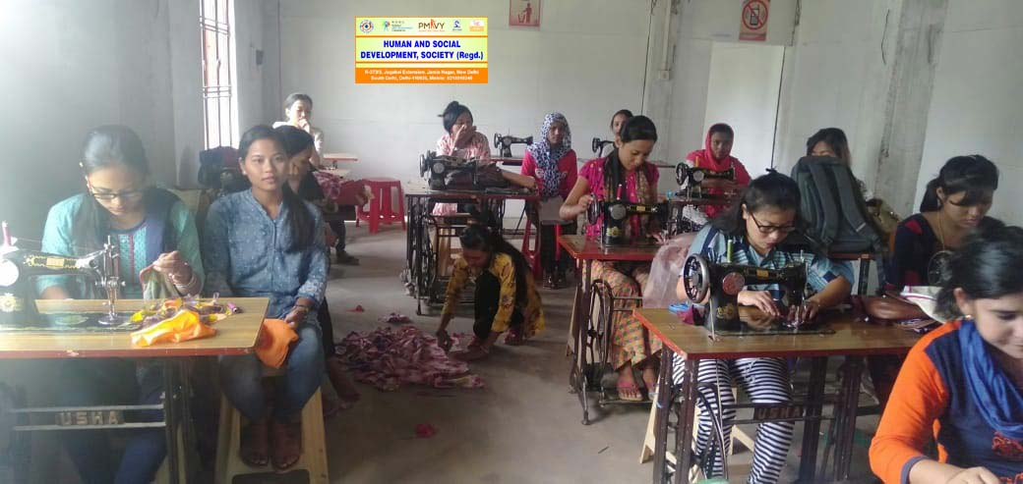

**Books distribution among Poor Students.**

We havedistributed books among poor students in the weaker and marginalised rural area of Nuh, Mewat, Haryana. Through this initiative we reach out to the children who are out of school because of their financial condition. Its is a very big area where underprivileged and poor families are living with very bad condition.

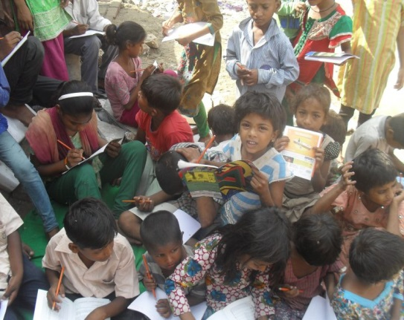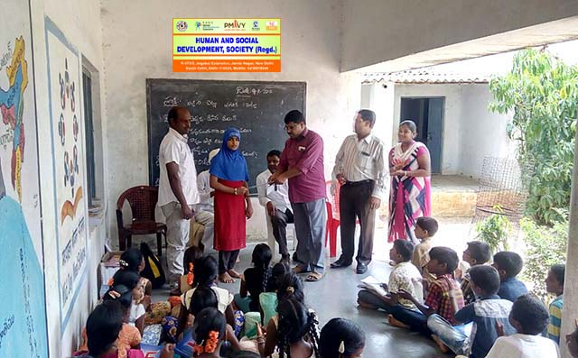

**Tree plantation and awareness programme.**

On the occasion of world environment day i. e. 5 June 2019, 200 trees were planted in the area of JJ Colony Madanpurkhadar, New Delhi. Further, the people living in the nearby area were awared regarding saving the trees and planting more trees in order to save our environment. Various people were also provided platform to share their ideas on ' how to save the earth?. Many youngsters including children shared creative ideas for the same.

**MOHAMMED ARSHAD**

General Secretary